A.D.I Dev - Website Storyboard
Recommended positioning
A.D.I Dev
Supporting Every Successful Build
Tender & Estimation | Project Management | Administration
We take care of the work behind the build, so you can focus on building the business.
The site should make three things immediately clear:
- We understand builders and construction.
- We provide practical people-based support now.
- We are building technology that will make that support even better.

1. HOME
Hero section
Visual: Our new A.D.I DEV logo, ideally over a high-quality image/video of a residential build or builder reviewing plans on site.
Headline options
My preferred:
Build More. Stress Less.
Practical support for the work behind every successful build.
Alternative:
You Build. We Support.
Taking the admin, coordination and estimating workload off your plate.
Then:
A.D.I DEV provides outsourced Tender & Estimation, Project Management and Administration support for small and medium-sized builders - helping you stay organised, keep projects moving and focus on what matters most: your clients, your sites and your growth.
CALL TO ACTION (CTA):
Let's Talk
Secondary CALL TO ACTION (CTA):
See How We Can Help

The problem
Building is your business. Admin shouldn't run it.
Small and medium-sized builders often find themselves doing everything:
- pricing the next job;
- chasing subcontractor quotes;
- preparing tenders;
- managing variations;
- following up suppliers;
- processing invoices;
- updating clients;
- coordinating trades;
- tracking project milestones;
- managing paperwork;
- and still trying to run the business.
The work behind the build is essential - but it can consume the time you should be spending on clients, construction, people and growth.
That's where A.D.I DEV comes in.
We become an extension of your team, providing practical support across Tender & Estimation, Project Management and Administration.

2. THREE SERVICE PILLARS
Use the three icons from our logo as the visual foundation.

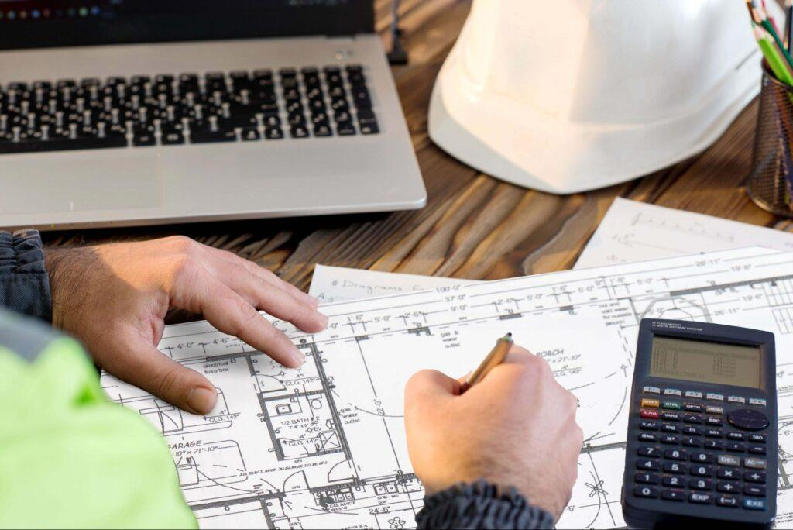

Tender & Estimation
Price with greater confidence. Tender with greater capacity.
From reviewing plans and specifications to preparing estimates, take-offs and tender documentation, A.D.I DEV can provide the additional capacity you need when your pipeline grows.
We can help with:
- Plan and specification review
- Quantity take-offs
- BOQ preparation
- Trade-by-trade estimating
- Subcontractor quote requests
- Quote comparison
- Scope reviews
- Tender preparation
- Tender documentation
- Pricing updates and revisions
- Inclusions, exclusions and assumptions
- Tender follow-up and tracking
Key message: More tender capacity without the immediate cost of another full-time resource.
Current Australian estimating providers similarly emphasise take-offs, BOQs, trade breakdowns, quote comparison and tender capacity.
CALL TO ACTION (CTA):
Explore Tender & Estimation Support →

3. PROJECT MANAGEMENT
Project Management
Keep projects moving. Keep everyone accountable.
Construction projects involve hundreds of moving parts. A.D.I DEV helps keep the back end organised so that actions, information and follow-ups don't get lost.
We can help with:
- Project setup and administration
- Project schedules and task tracking
- Subcontractor coordination
- Supplier coordination
- Client communication
- Meeting preparation and minutes
- Action registers
- RFI tracking
- Variation tracking
- Progress claim administration
- Procurement tracking
- Document control
- Defect and completion tracking
- Handover documentation
- Regular project reporting
Less chasing. More control.
We help you keep track of what needs to happen, who needs to do it and when it needs to happen.
CALL TO ACTION (CTA):
Explore Project Management Support →

4. ADMINISTRATION
Administration
Take the paperwork off your plate.
Good administration keeps a construction business moving. But when you're running multiple projects, admin quickly becomes a backlog.
A.D.I DEV can take responsibility for the day-to-day administrative workload, so you don't have to.
We can help with:
Accounts & Finance Administration
- Accounts payable
- Accounts receivable
- Invoice processing
- Supplier invoice management
- Payment preparation
- Client invoicing
- Payment follow-up
- Reconciliation support
- Purchase order administration
General Administration
- Data entry
- Document preparation
- Filing and document control
- CRM updates
- Scheduling
- Meeting coordination
- Reporting
- Follow-ups
- Maintaining registers and spreadsheets
Construction Administration
- Contract administration support
- Variation registers
- Compliance registers
- Subcontractor documentation
- Insurance/licence tracking
- Project records
- Client correspondence
We handle the details. You stay focused on the build.
CALL TO ACTION (CTA):
Explore Administration Support →

5. A.D.I DEV VALUE PROPOSITION
This should be a prominent section on the homepage.
More than outsourced staff. An extension of your team.
NOTE: We should avoid making our core proposition: "We provide offshore workers."
Instead: A.D.I DEV provides people, processes and technology to help builders run better businesses.
One team. Three areas of support.
Tender & Estimation
↓
Project Management
↓
Administration
All working together.
NOTE: A builder might initially engage A.D.I DEV for administration but gradually use the same resource for project coordination, tender preparation and estimating support.

6. WHO WE HELP
Built for builders like you
Small Builders
You're managing the business, the site and the clients - often all at once.
A.D.I DEV gives you back time.

Growing Builders
You're winning more work but don't want to immediately add another layer of permanent overhead.
A.D.I DEV gives you scalable capacity.

Established Small-Medium Builders
You've got a team, but the workload isn't always predictable.
A.D.I DEV gives you additional support when and where you need it.

Builders Who Are Growing Too Fast
More projects mean more:
- paperwork;
- invoices;
- subcontractors;
- client communication;
- tenders;
- coordination.
A.D.I DEV helps your back office keep pace with your construction pipeline.
NOTE: This is consistent with current construction outsourcing positioning: support is particularly valuable where businesses are growing but aren't yet ready to build a large permanent internal team.

7. BENEFITS
What A.D.I DEV gives you
Maybe use six simple icons.
More Time
Spend more time on clients, sites and growth.
Greater Capacity
Take on more work without immediately increasing permanent overheads.
Better Organisation
Keep tasks, documents, follow-ups and information under control.
Greater Visibility
Know what's happening across your projects.
Reliable Support
Have someone actively following things up rather than waiting to be told.
Scalable
Increase or change the support you need as your business evolves.

8. PROACTIVE SUPPORT - IMPORTANT DIFFERENTIATOR Question: Should this be a separate section because it reflects the expectation we set for our A.D.I DEV personnel?
We don't just wait for instructions.
We believe good support means being proactive.
A.D.I DEV personnel are expected to:
Identify
Spot issues before they become problems.
Ask
Seek information when something doesn't make sense.
Follow Up
Chase outstanding actions, quotes, documents and approvals.
Communicate
Keep you informed about what's happening.
Improve
Look for better ways to organise and manage the work.
The philosophy:
Don't just complete the task. Understand why it matters.

9. HOW IT WORKS
Getting started is simple
01 - Tell us about your business
We'll understand your projects, systems, workload and where you're spending too much time.
02 - Identify the opportunities
We'll identify the areas where A.D.I DEV can provide the greatest value.
03 - Meet your A.D.I DEV support team
We allocate the right resources to your business and establish how we will work together.
04 - Integrate with your systems
We work within your existing systems, processes and ways of doing things.
05 - We get to work
Your A.D.I DEV team begins taking responsibility for the agreed workload.
06 - Improve and scale
As we understand your business, we identify opportunities to improve processes and increase the value we provide.

10. PEOPLE + TECHNOLOGY
NOTE: This is very important to our long-term positioning. We don't want to make the software sound like an afterthought.
Today: People
Tomorrow: People + Technology
A.D.I DEV is starting with people.
Our experienced A.D.I DEV team provides the practical support your business needs today.
At the same time, we're developing technology specifically designed around the way residential builders operate.
Technology shouldn't replace people. It should make good people better.
Our platform will help A.D.I DEV personnel:
- organise information;
- manage tasks;
- track projects;
- streamline administration;
- improve communication;
- standardise processes;
- reduce repetitive work;
- provide greater visibility to builders.
The result
Better people + better processes + better technology.
NOTE: This is a particularly attractive positioning because there are already construction technology providers combining estimating/project management software with human support.

11. ABOUT A.D.I DEV
Built around one simple idea
Builders should spend more time building.
A.D.I DEV brings together three diverse professionals with decades experience in:
- building and construction;
- strategy and operations; and
- technology, process and systems.
We are united by a common passion:
Helping people focus on what they do best.
We understand that running a building business isn't just about building.
It is also about:
- winning work;
- pricing jobs;
- managing projects;
- communicating with clients;
- coordinating trades;
- processing invoices;
- managing documents;
- following up outstanding tasks; and
- constantly keeping the business moving.
Our objective is simple:
Take the day-to-day administrative and coordination workload off builders so they can focus on higher-value activities - managing clients, delivering projects and growing their business.
Our vision
To become the trusted operational support platform for small and medium-sized builders.
Starting with people.
Building technology.
Creating a better way to run construction businesses.

12. WHY A.D.I DEV?
Why builders choose A.D.I DEV
NOTE: Include suitable icons for each point below
Construction-focused
We understand that construction isn't a generic office environment.
One partner across three functions
Tender & Estimation. Project Management. Administration.
Flexible support
Get support where your business needs it rather than building every capability internally.
Proactive approach
We don't simply wait for instructions.
Process-driven
We aim to create repeatable processes rather than relying on individuals remembering what needs to happen.
Technology-enabled
Our people are supported by technology being developed specifically around construction workflows.

13. CAREERS
Join the A.D.I DEV Team
Help builders build better businesses.
We're building a team of people who enjoy solving problems, taking ownership and helping others succeed.
If you are:
- organised;
- proactive;
- commercially minded;
- comfortable working independently;
- a strong communicator;
- interested in construction; and
- passionate about providing great support,
we'd love to hear from you.
We're looking for people across:
- Administration
- Project coordination
- Construction administration
- Tender & estimation
- Technology & systems
Join our growing team
Form fields:
Full Name*
[ ]
Email Address*
[ ]
Phone Number*
[ ]
Location / Suburb*
[ ]
Postcode*
[ ]
Area of Interest
[Administration / Project Management / Tender & Estimation / Other]
Upload Resume
[Choose File]
Tell us a little about yourself
[ ]
Submit Application
CALL TO ACTION (CTA):
Become part of A.D.I DEV

14. CONTACT US
Let's talk about your business
You don't need to know exactly what support you need.
Tell us what's taking up your time, what's falling behind or where your team is under pressure.
We'll help identify where A.D.I DEV can make the biggest difference.

Talk to A.D.I DEV
Phone:
[04XX XXX XXX]
Email:
[info@adidev.com.au]
Website:
www.adidev.com.au
Location:
Sydney, NSW

Send us an enquiry
Full Name*
[ ]
Business Name*
[ ]
Business Website
[ ]
Phone Number*
[ ]
Email Address*
[ ]
How can we help?*
[ ]
Message
[ ]
Submit
CALL TO ACTION (CTA)button:
Let's Talk

15. FOOTER
Keep this very clean.
A.D.I Dev
Supporting Every Successful Build
Tender & Estimation | Project Management | Administration

Services
- Tender & Estimation
- Project Management
- Administration
Company
- About
- Careers
- Contact
Legal
- Privacy Policy
- Terms & Conditions
Contact
[Phone]
[Email]
© 2026 A.D.I Dev Solutions. All Rights Reserved.

NOTE: WEBSITE SHOULD BE WEB BROWER AND MOBILE FRIENDLY

